Asynchronous programming in .net

Spis treści

Async and Await in .Net 2

Definition 2

Using Parallel Task in .Net 5

Combine Task into async chain 5

Always Continuation - how to handle with? 6

Cancel a Task 7

Figure out which Tasks are completed 9

Test Async method 9

Concurrency Bag 10

Come back to Main Context 10

Key to use a Task 11

Parallel Extension 12

Definition 12

Collect Data with Parallel 13

Lock operation 14

Asynchronous Deep Dive 15

Introduce 15

Send Pack of Data as result 16

Task Completion Source 16

Attach or Detach task from chain 17

Implication of async 18

Deadlock 19

Async Stream 20

# Async and Await in .Net

## Definition

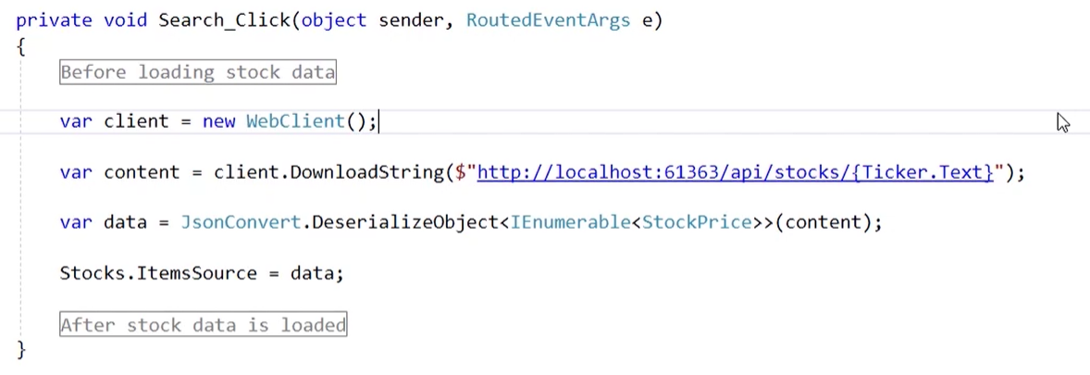

Look this is a normal sync method. Synchronous means all operations will be execute in queue whe first will be done the second will start.

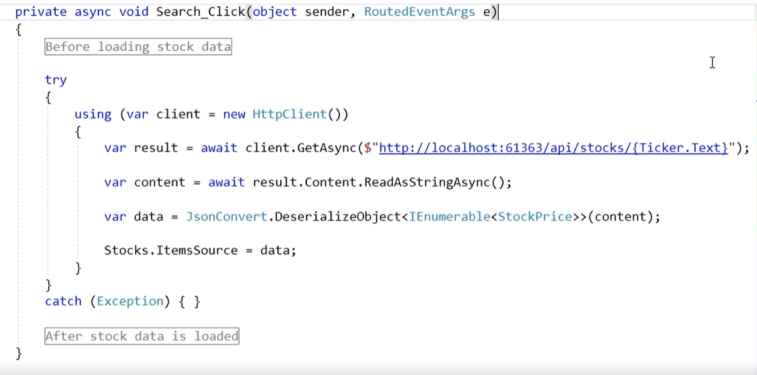

On this image is async method. On the first look, there are few differences. First is try and catch block but is it element of C# language and it is use to catch exception and handle with it. But is few this most important there are key words async and await. First mark operation as asynchronous and second wait for result of method. Async version of method don’t lock up thread. Both of words are use together alweys.

Await key word get result when is ready. Await is waiting for result and then start execute rest of method.

Async method invoke is in separate thread not in main thread if application.

Continuation is second operation after async method is complete (look on result and content), and back to main thread.

\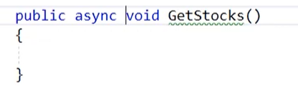

Never declare method as async void. This is Fire and forget all data disappear after this method. State machine don’t return a task with result.

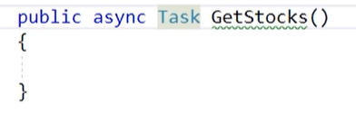

Always declare async as Task. This method don’t require a return value.

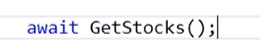

When call async method use await keyword. Remember this is pair and always it must appear together.

If dev forgets about await then doesn’t get information about exception and app will be deadlock.

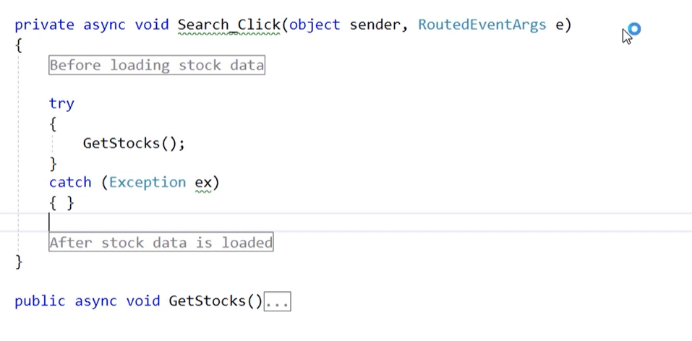

Even if invoke method will be inside try and catch block.

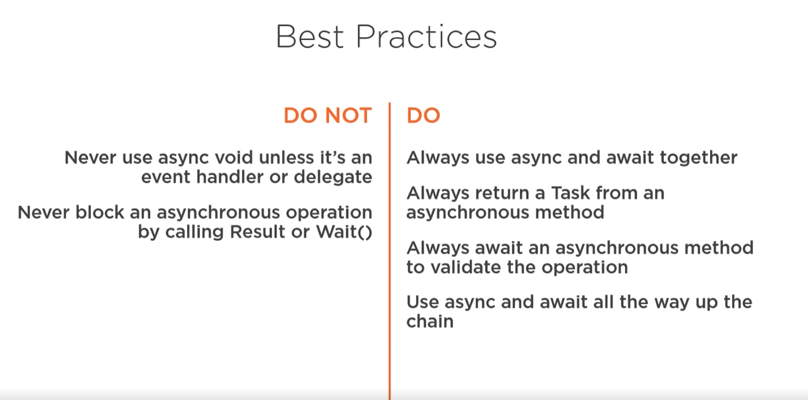

# Using Parallel Task in .Net

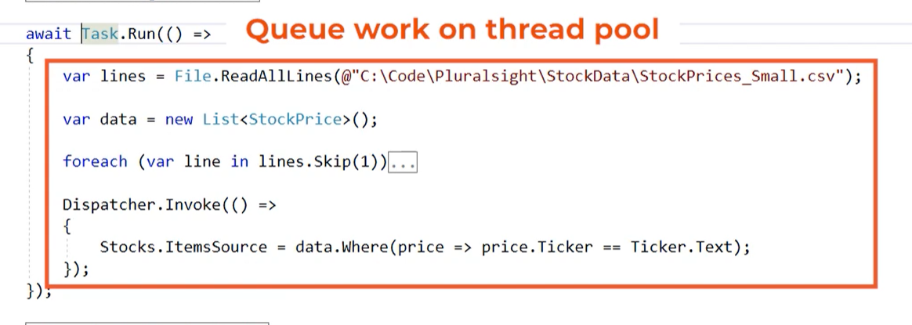

Code can be divided to thread pool and wait for invoke all line even a sync. Task of course has a generics version to return a T type result.

## Combine Task into async chain

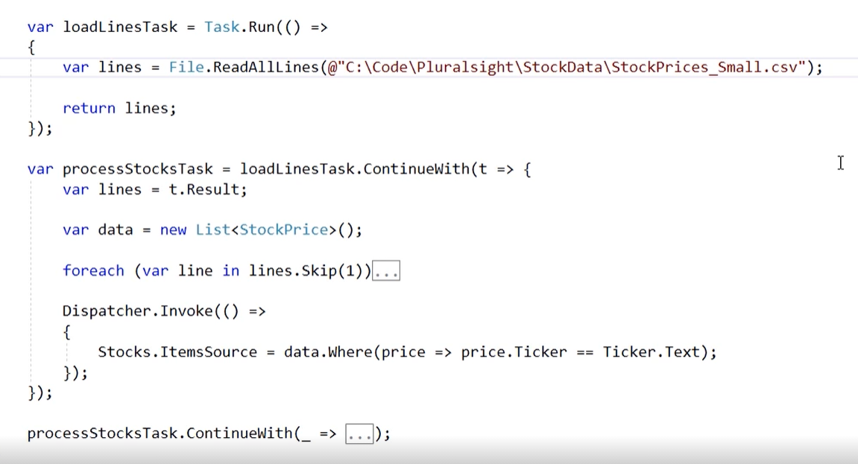

Result of Task action can be assign to var. This property can be passed to another async method to use this feature required is ContinueWith method.



There is a one difference between task and Continuation so be careful.

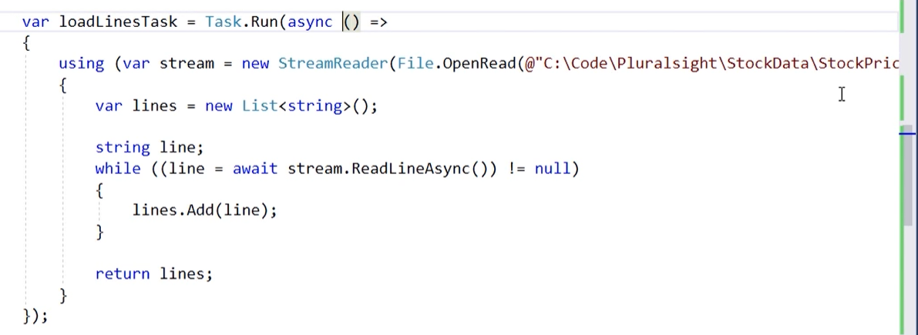

So to avoid occupy another thread, better is use async and await keywords. To use async anonymous function required is a … async keyword it easy. Isn’t it?

## Always Continuation - how to handle with?



Second different between asyn and continuation.

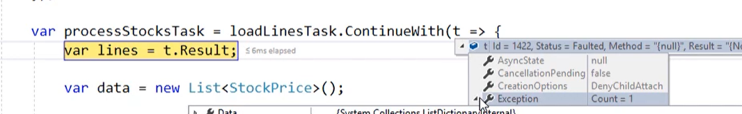

When some code fails result will collect or exception and keep going to invoke all method in chain.

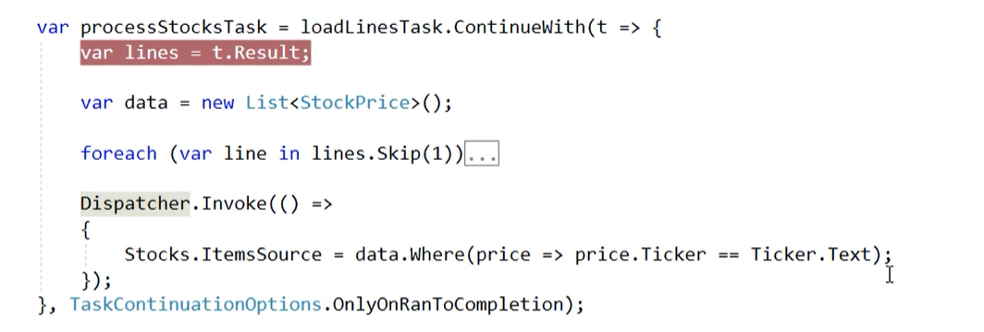

To skip another operation in chain required is a TaskContinuationOptions set to only Completion.

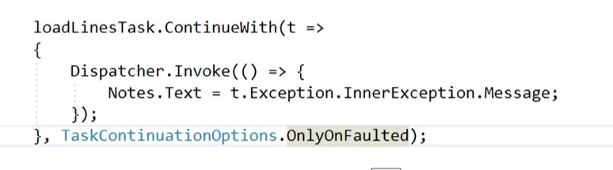

The same property can be used when some operations fail.

## Cancel a Task



This toke send information to previous operation to terminate immediately.

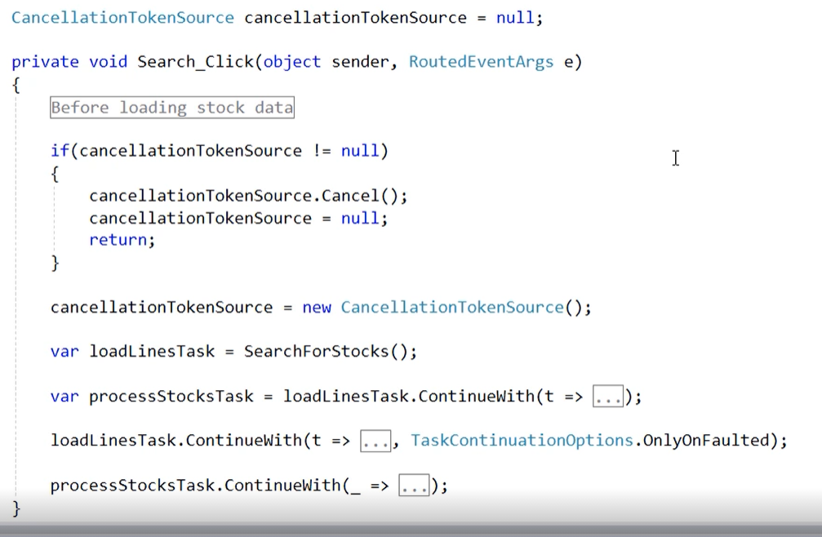

When cancellationToken is different than null operation will be terminate, but don’t send a message to actual running operations.



Token can be passed to another async method as parameter.

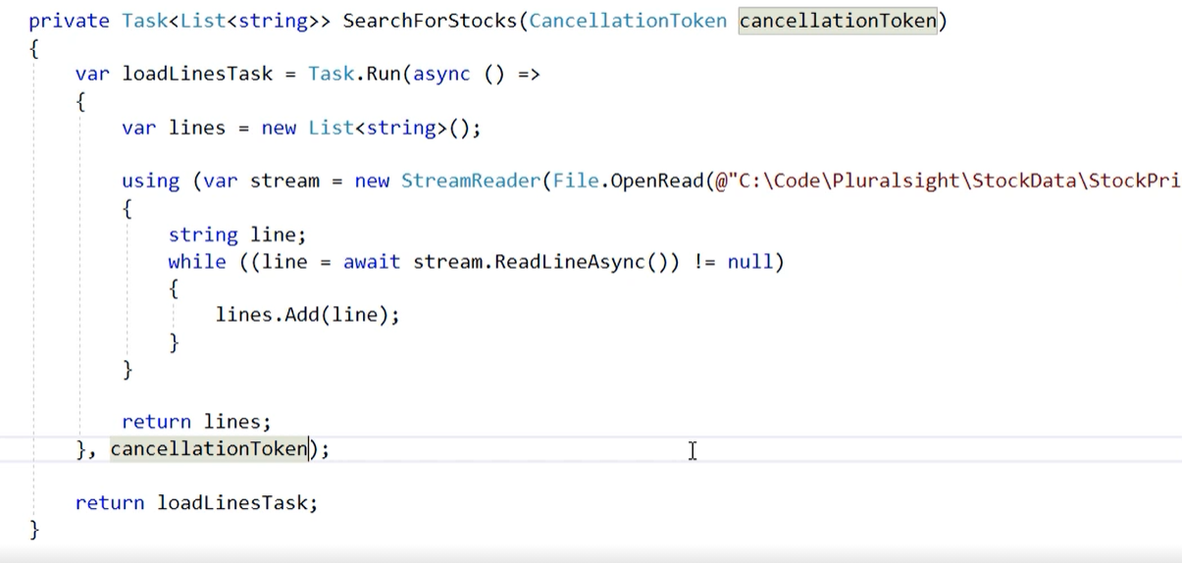

In anonymous function cancelation token can be used as second param to doesn’t execute operation.

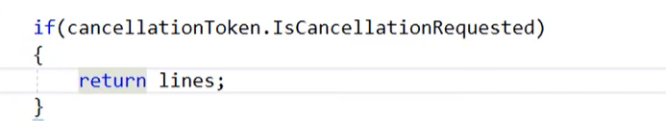

To make operation stop use token.IsCancellationRequest and throw an Exception which will be wrapped into Task with rest of data and finally operation stop. But records download will be return up to the moment when cancellation appears.

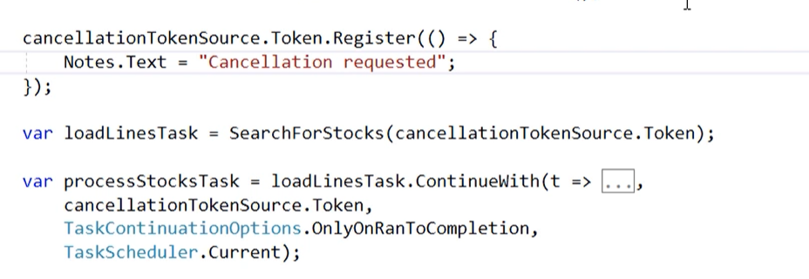

Token can hold information designed to UI.

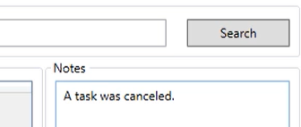

## Figure out which Tasks are completed

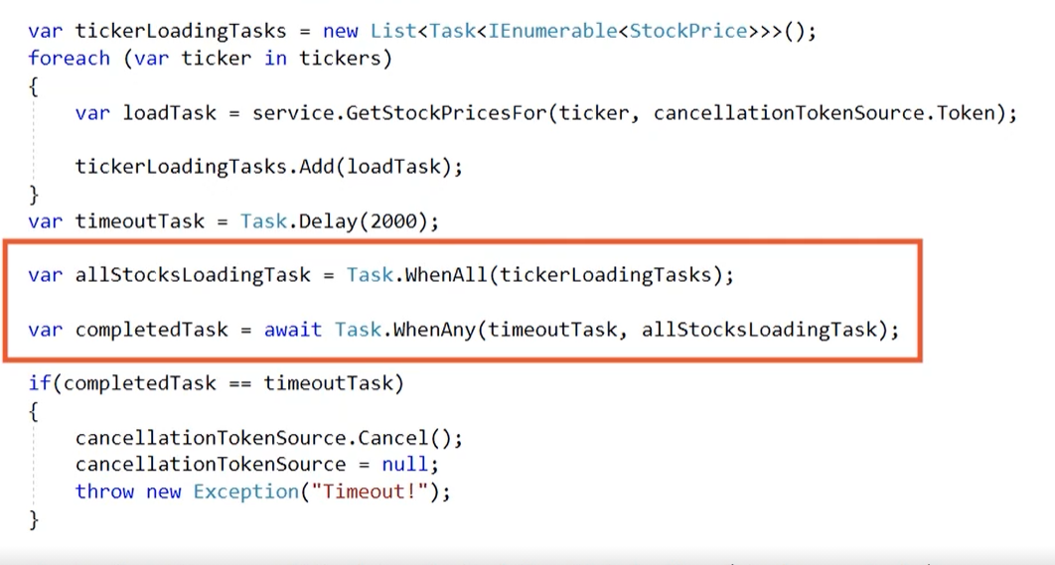Ok it’s a lot of to describe. So, Task can be added into a Collection. All of them can be invoke to do an operation like in on the example in for each loop. Task can be delay be delay method. Method Task.WhenAny or All return data when any of task is completed or all of them. Task can have set a timeout to cancel with cancel token.

## Test Async method

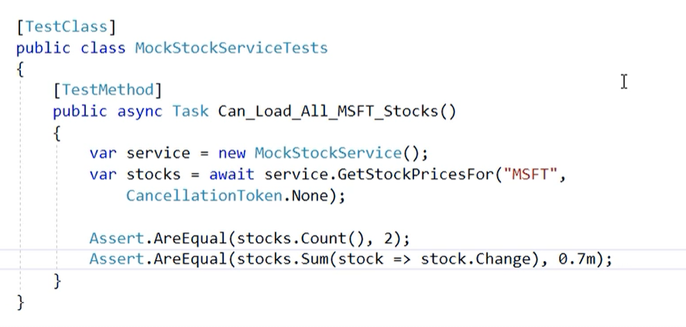

## Concurrency Bag

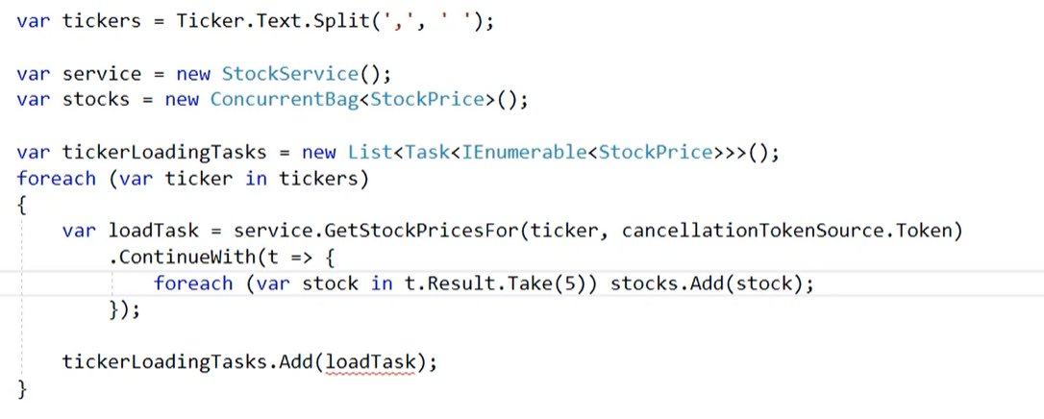

There are more thread safe collection. ConcurrentBag from this group. Thread safe collection can be used in async method without data leak or override. Each portion of information will be transfer to result and added to collection, of course this type of data can load more and more information and in the same time display in UI.

## Come back to Main Context



Continuation can come back to main context to use this feature required is a Configure await with false as parameter. Don’t come back to orginal threat after operation.

This should be invoke when dev doesn’t care about main thread and performance has to focus on another tasks. This in not used in ASP.Net Core.

Asp.net core not synchronize context after tasks.

## Key to use a Task

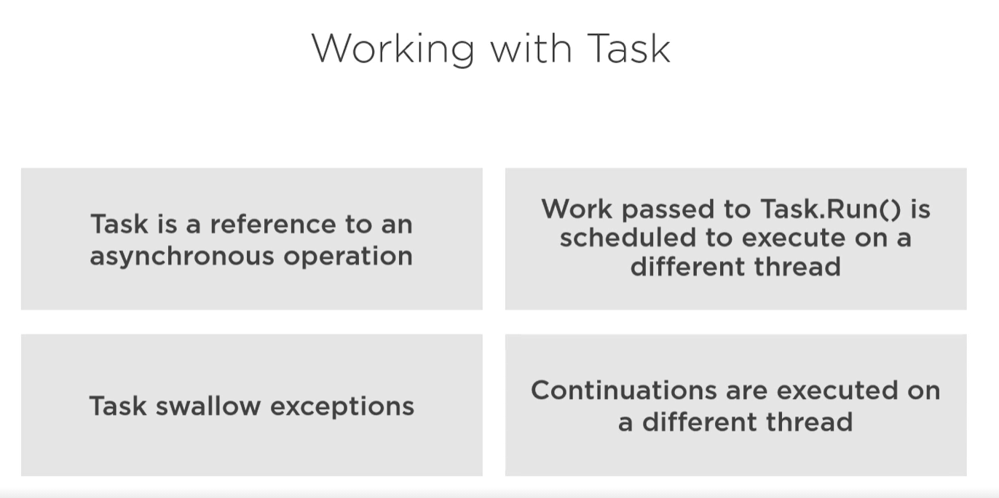

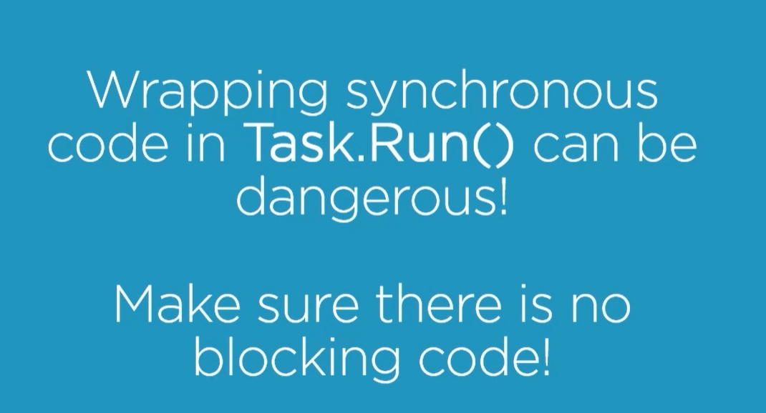

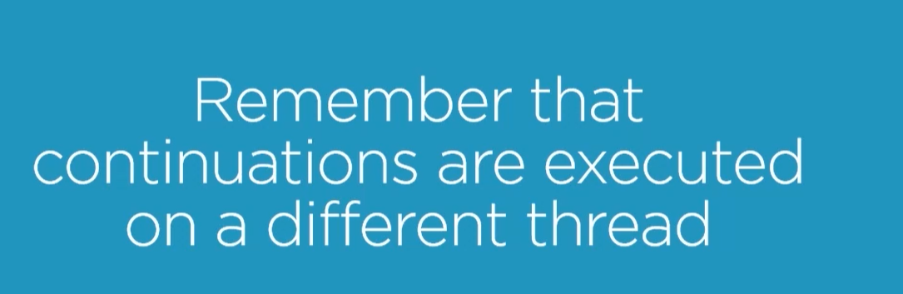

# Parallel Extension

## Definition

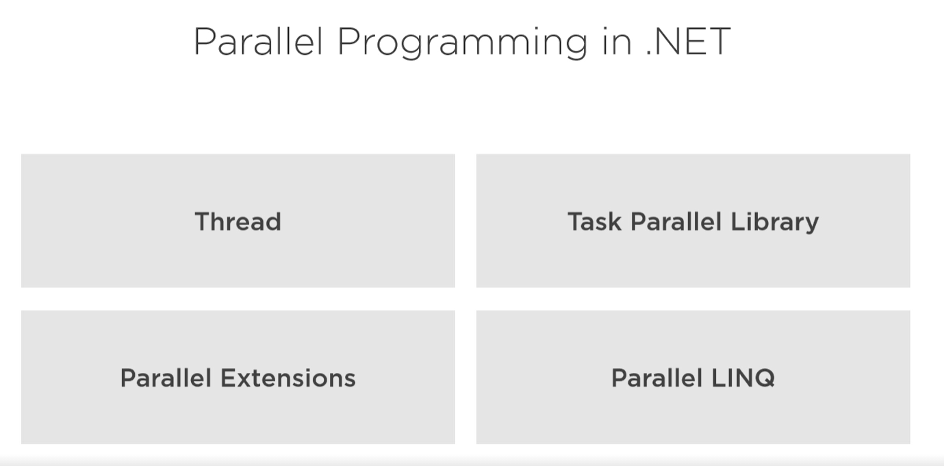

Parallel count the most efficient way to do method.

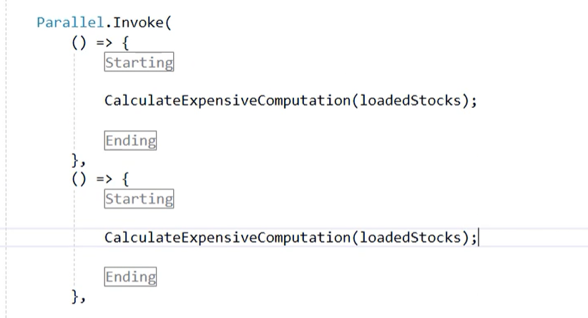

Parallel has own loop or invoke brackets.



Parrallel distribute work to threads. But it block UI too.





Parallel has max amount of actual running operations.

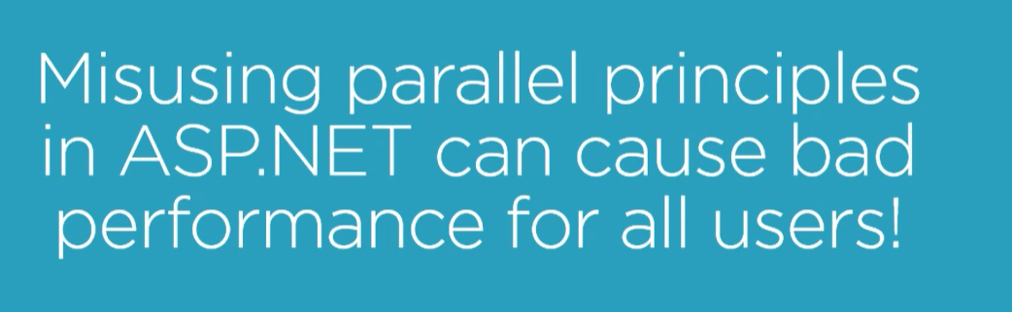

Because Parallel can block some action it means it can block some users ☺. Just don’t use it.

## Collect Data with Parallel



When Parralel is wrapped to Task some Thread can be releases.

With Parrallel use a Thread safe collection.



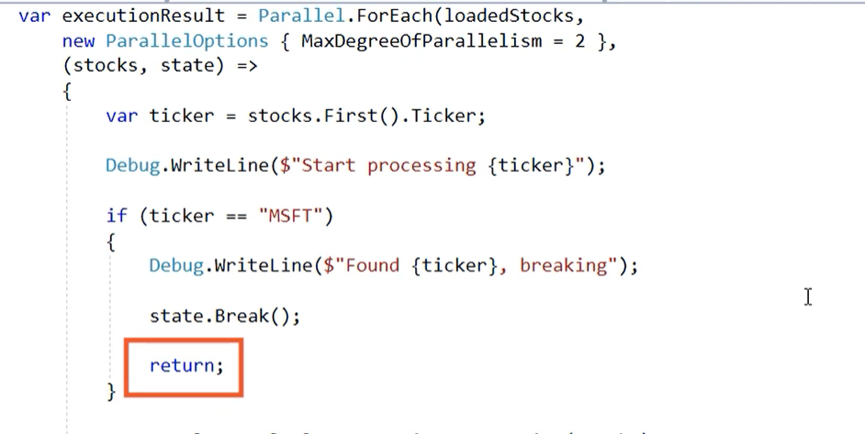

## Lock operation

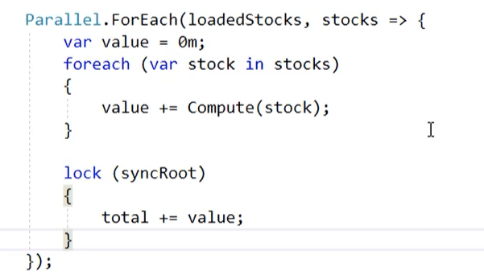

This method is of programming is required when dev needs e a value shared between threads.

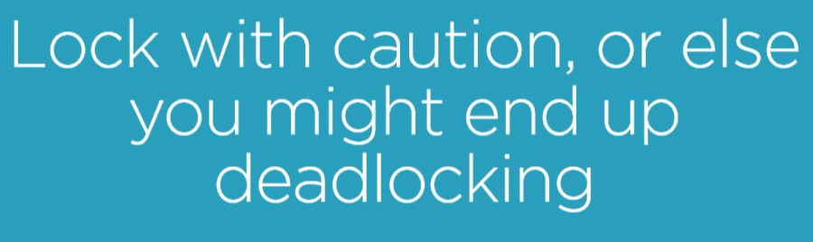

# Asynchronous Deep Dive

## Introduce

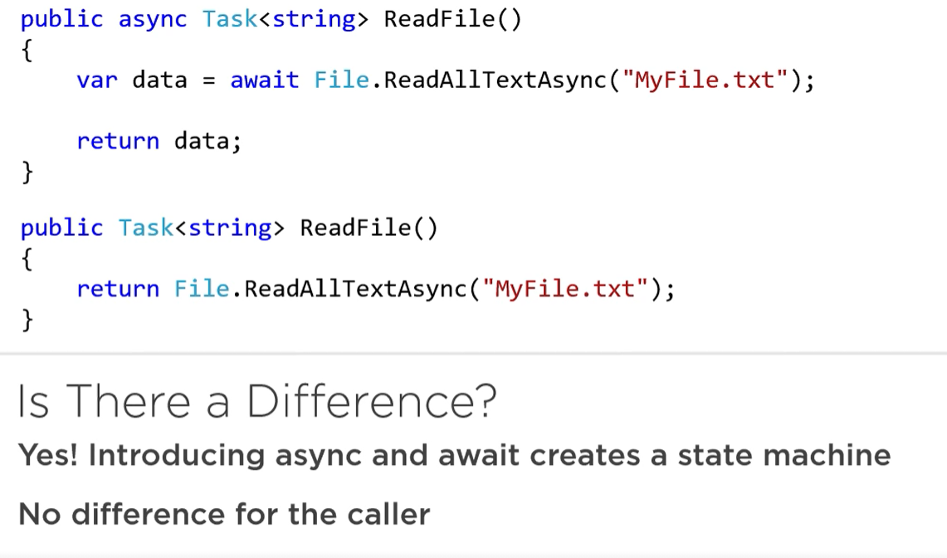

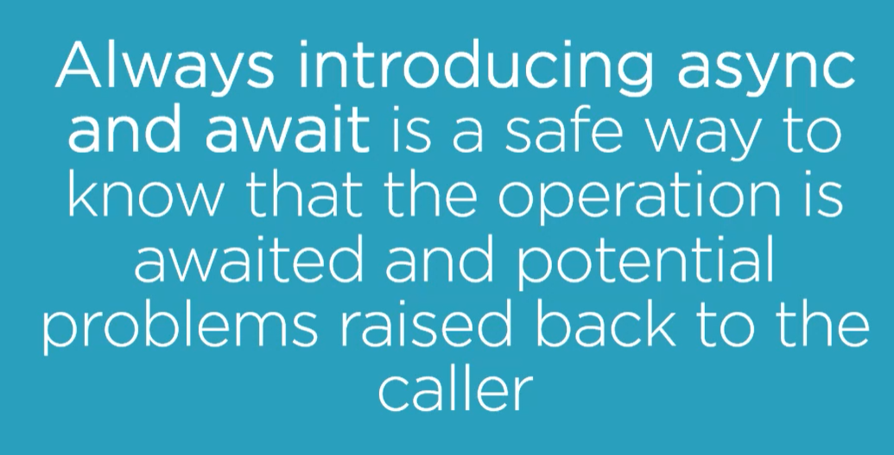

## Send Pack of Data as result



So use a Progress<T> class



To connect this mechanism with async method, dev needs Dispacher



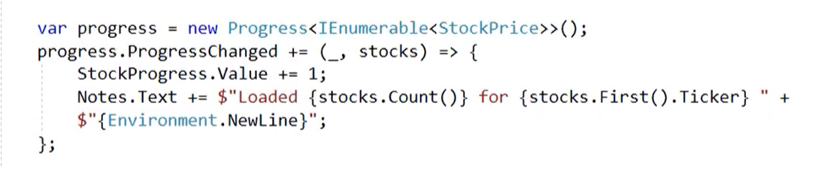

Code looks like above.

## Task Completion Source



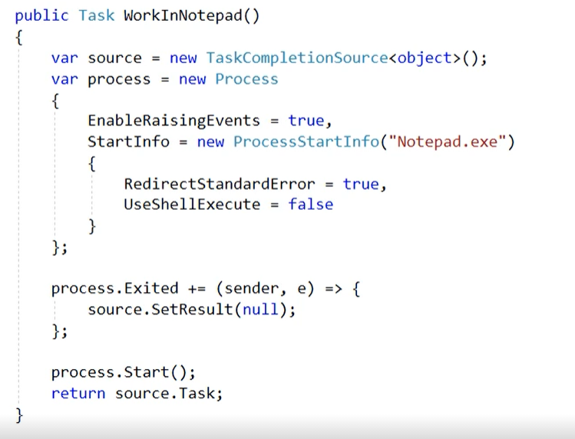Great technique but don’t use it.

## Attach or Detach task from chain

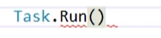

Create under a Task factory which allow to start new one.

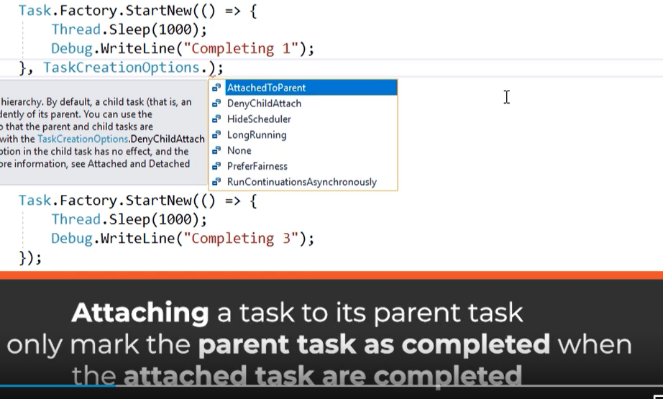

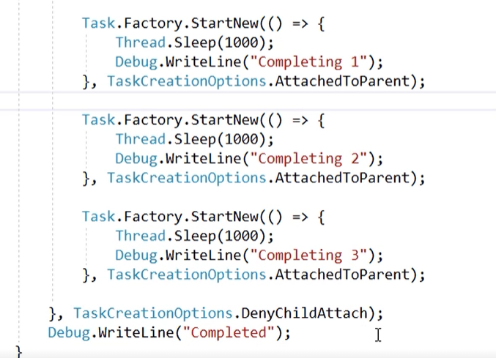

In this example first finished code will be last one because is detached from synch path of parent. Rest of task works on the same threat like parent and will be mark as complete when all parent and nested child task will be complete.

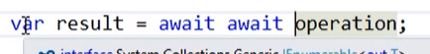

When there is double await so program must wait for rest of tasks. This is a IEnumerable<T>



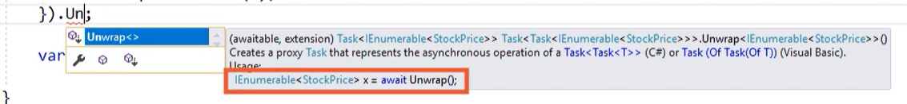

When to avoid await await keyword us Unwrap(). This method create Task of <Task<T>> and now there is no need to keep double await on return.

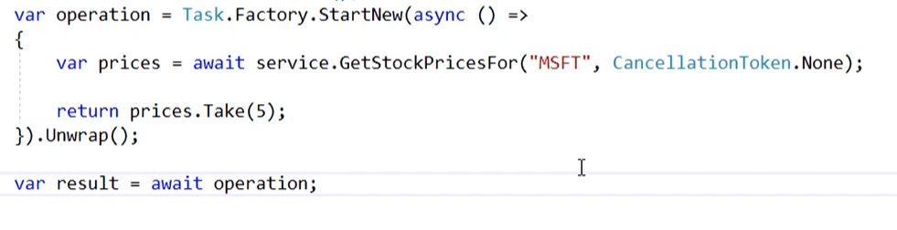

## Implication of async

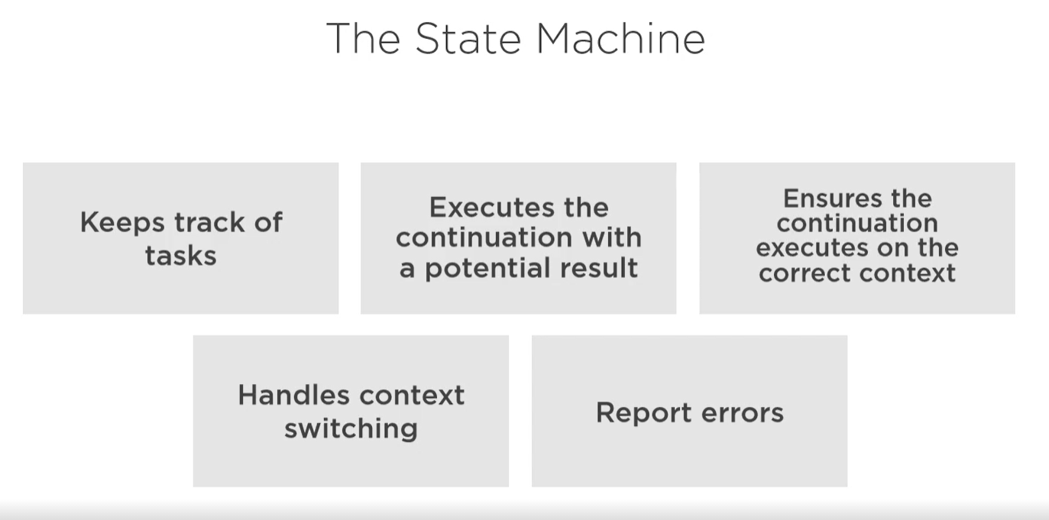

State machine tasks.

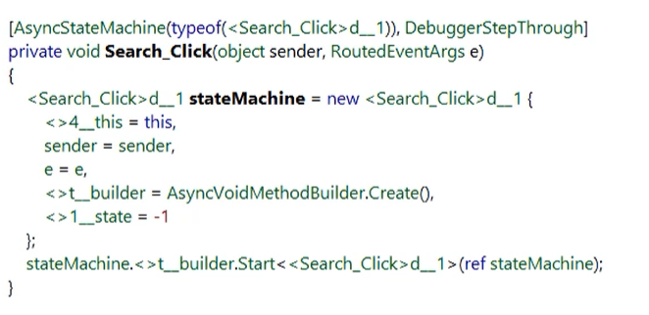

Under async keyword created is a state machine by compiler. State machine care for a continuation too. And exist as long as all continuation will be finished.

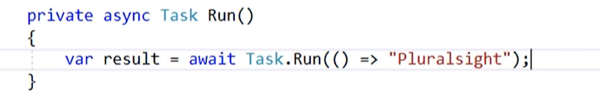

When method is marked as Task. State machine create task which is placeholder for each return value or exception. State machine go to operation wait to method is finished when this time comes them state machine comeback to main context with result of Task.

## Deadlock

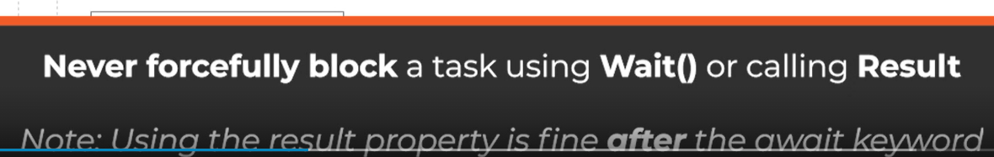

Using this type of keyword without await execute result or wait in main context but don’t wait for result create for state machine when this result will be complete then should be send to main thread, but in main context all operation has been execute and now one threat waiting for send result but second don’t take this output because all code has been execute.

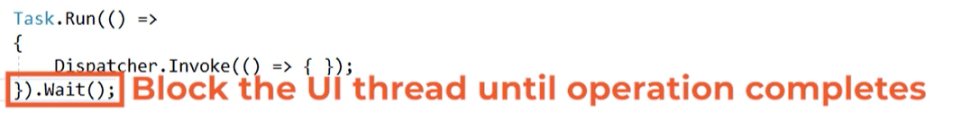

This I possible.

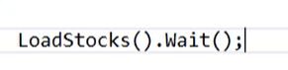

This is illegal

In deadlock one operation doesn’t access to because second is using this context.

## Async Stream

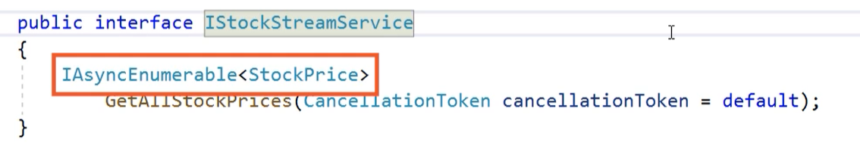

IAsyncEnumarable support async return some part of data with yield return.

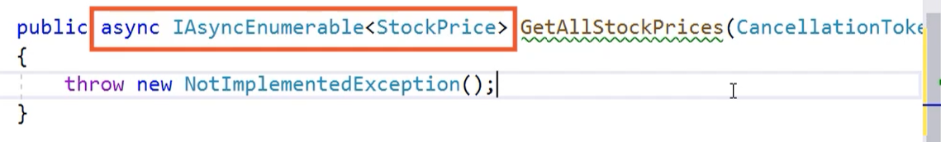

Remember about async

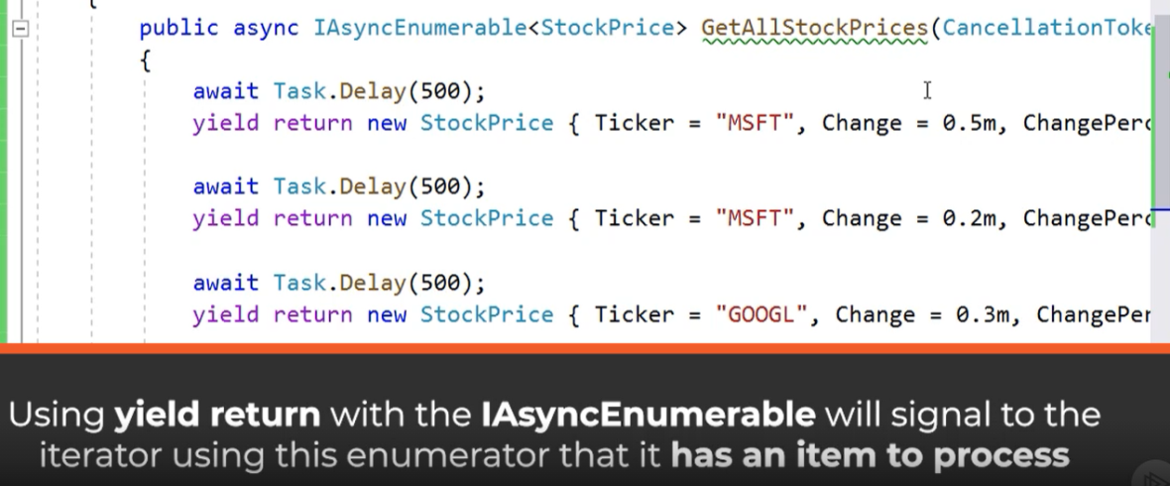

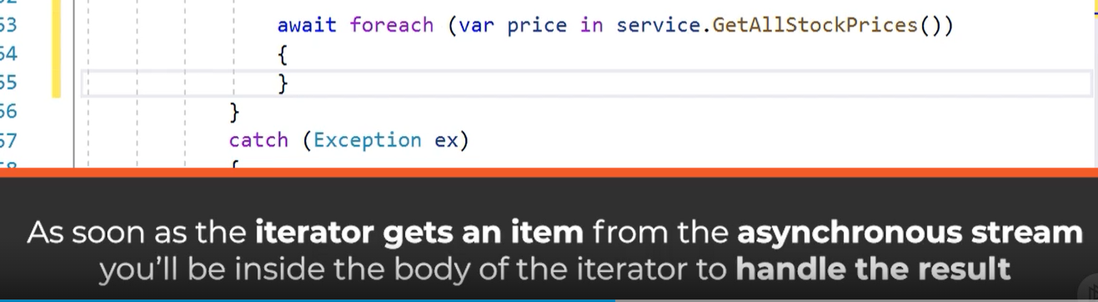

For each item in AsyncIEnumerable required is await keyword for before foreach loop.



With this method can be used a cancellation token ☺.